PYTHON ASSESSMENT

20-12-2023

1.Explain Python Module with examples a.Import module in Python .Renaming the Python module

-> Module is a file which contains functions to do many tasks

like math module contain function like pow() , sqrt() etc.

User Defined Module

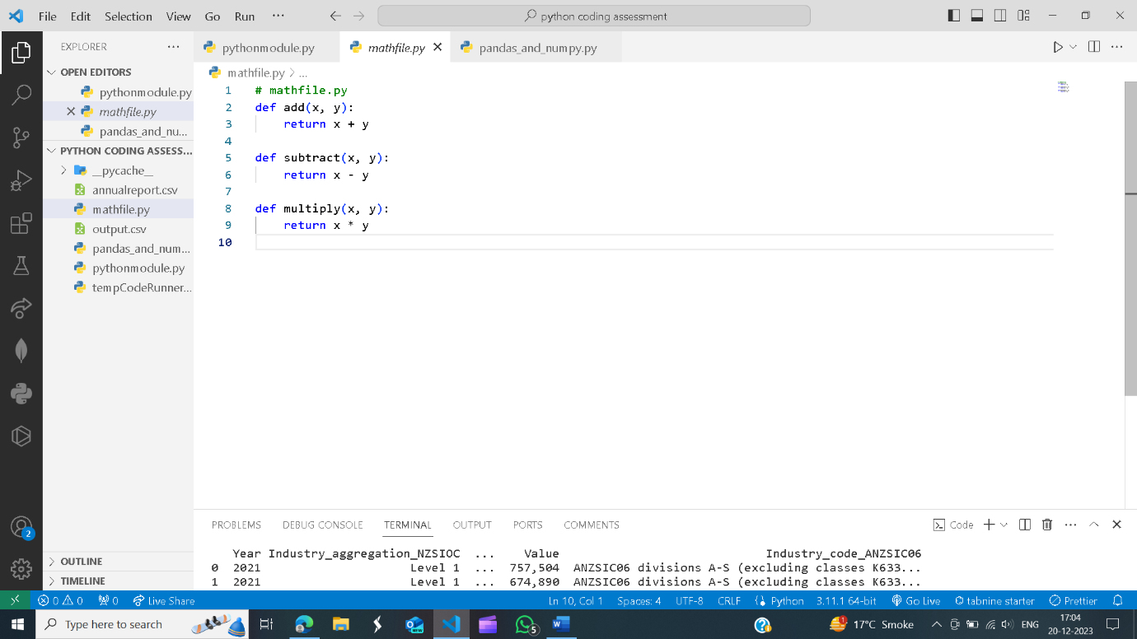

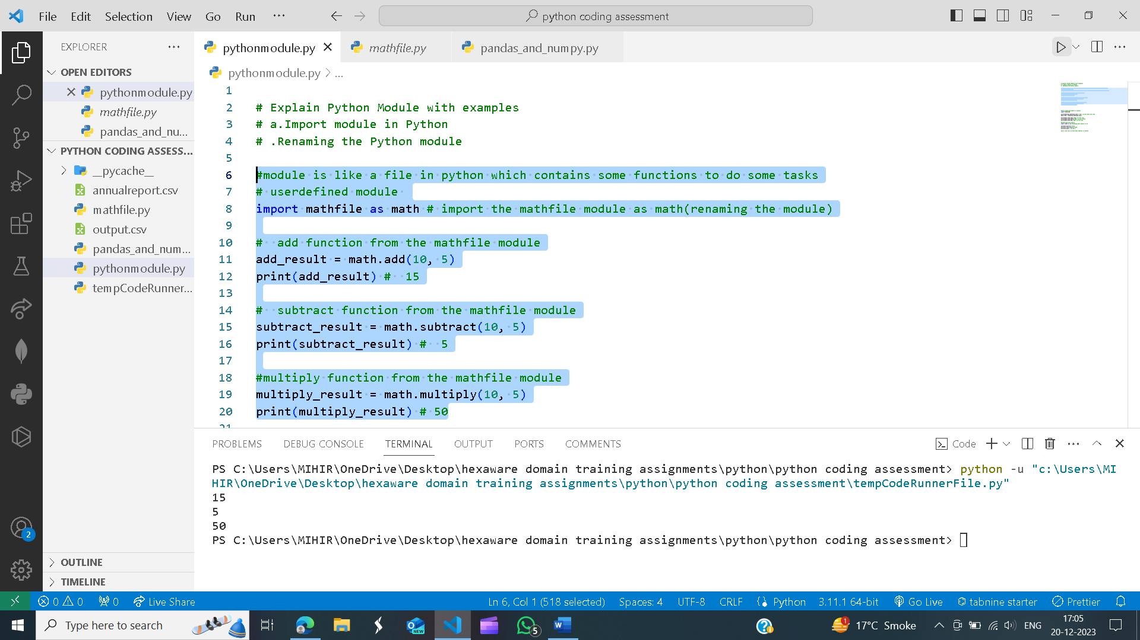

Predefined modules in python

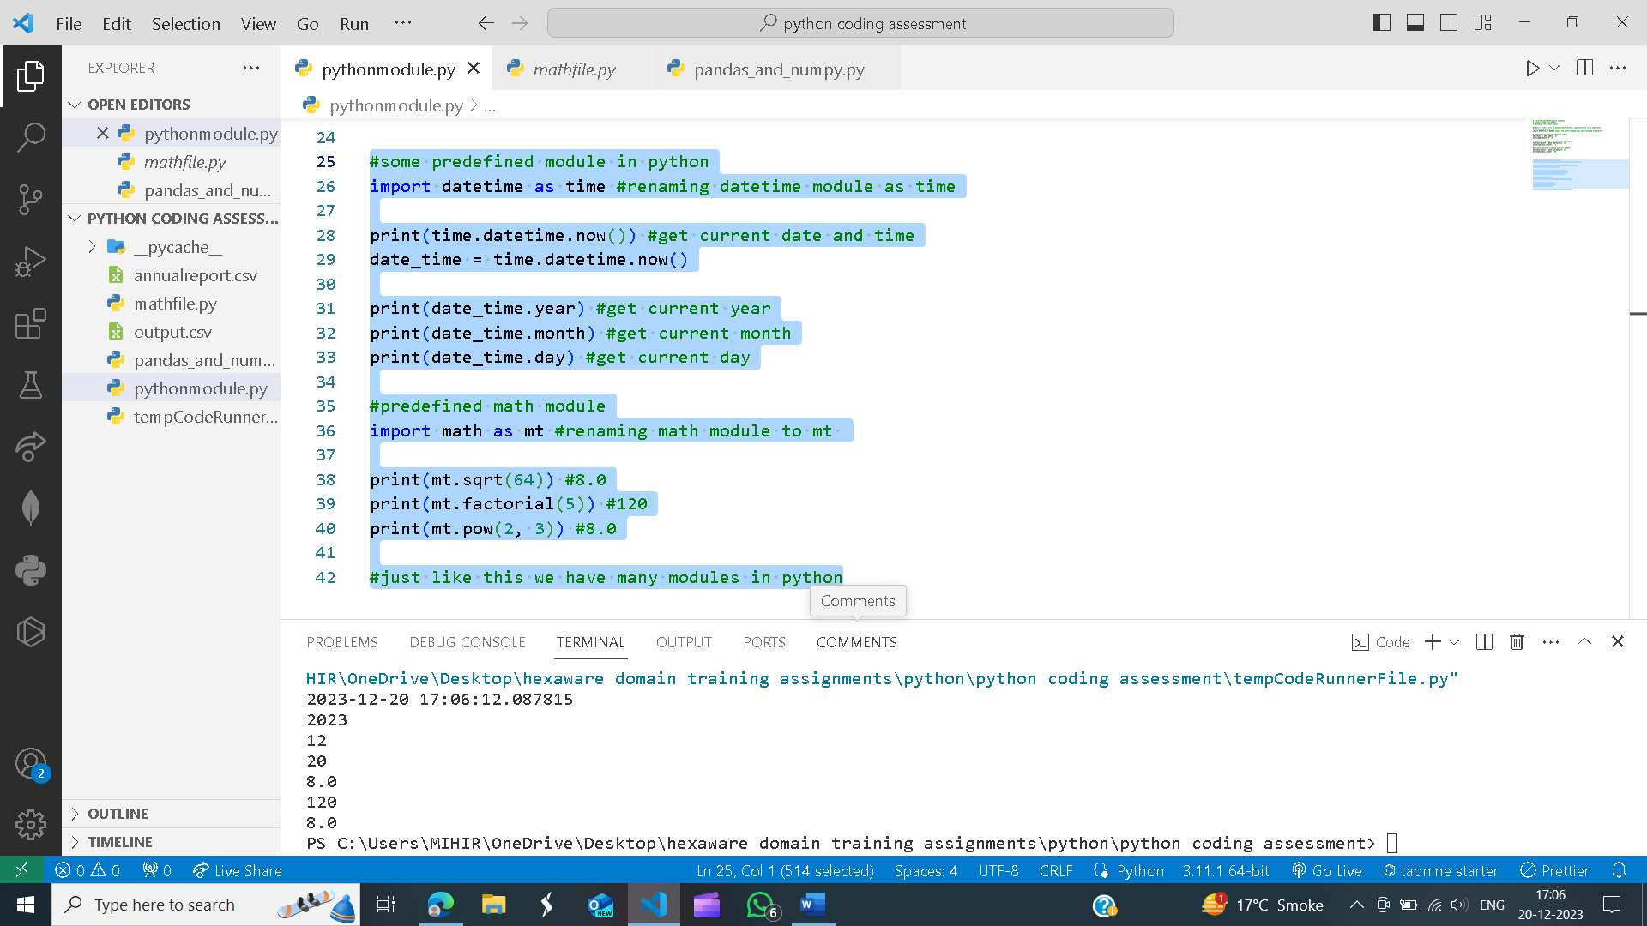

2.Explain Pandas and numpy using Examples in PYTHON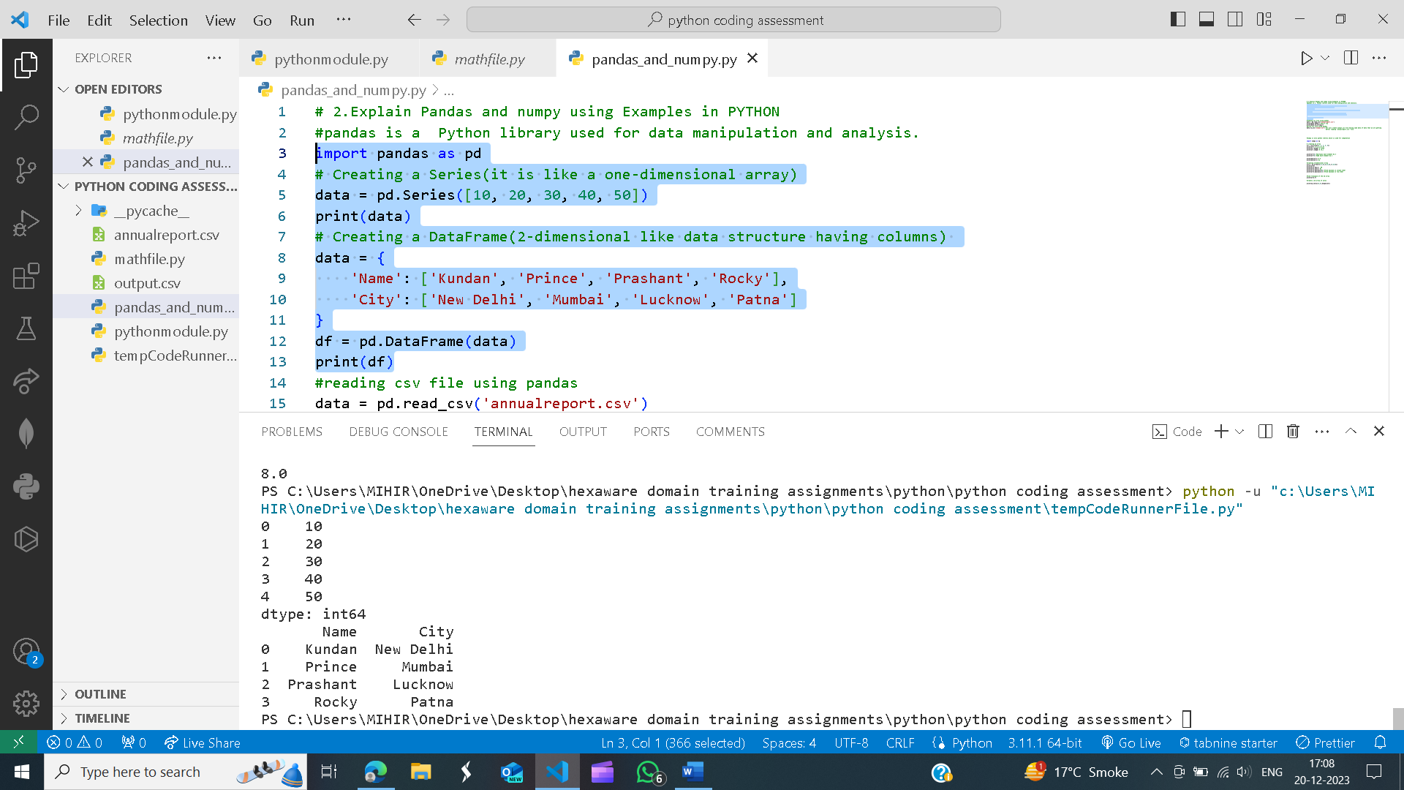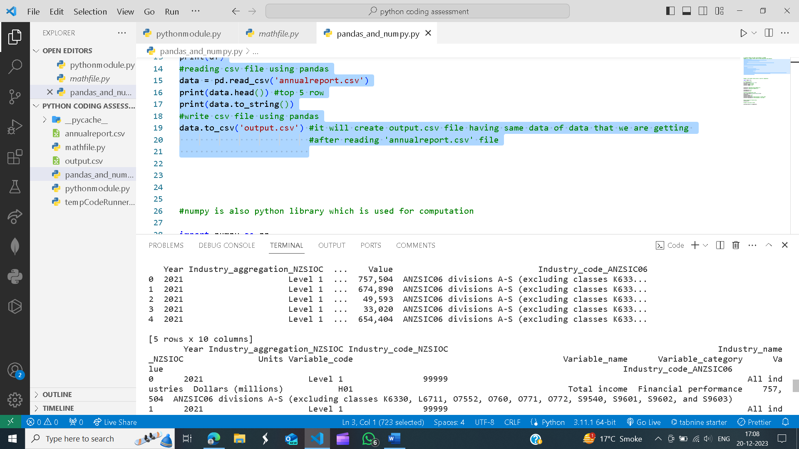

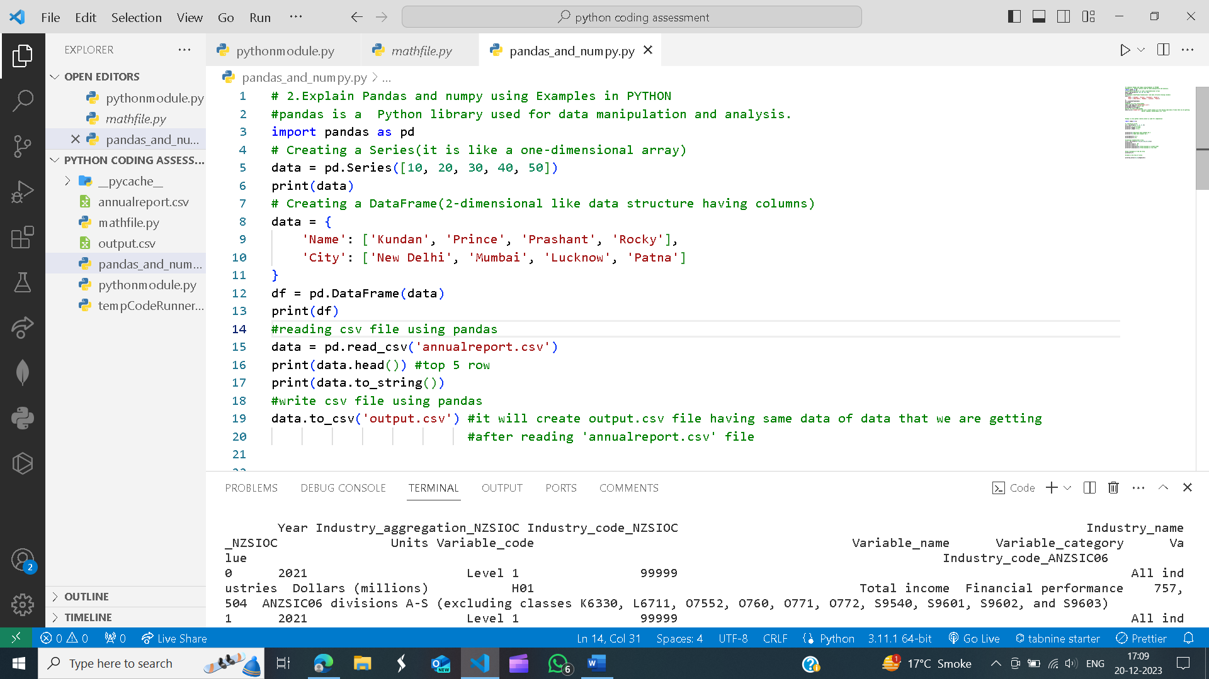

Numpy